**Assembling the CPU**

1. Put the Processor into the slot correctly checking the arrow on the processor with the arrow on the motherboard. The Processor has to be placed very carefully as a single pin damage on the processor or the slot could make the motherboard useless.

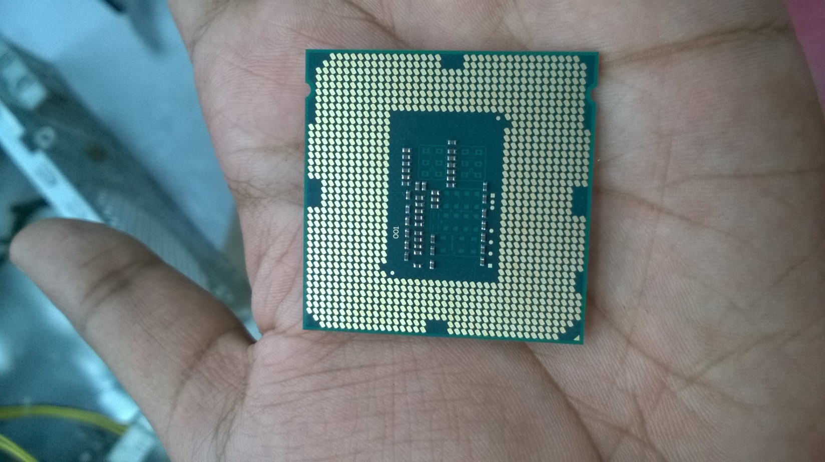 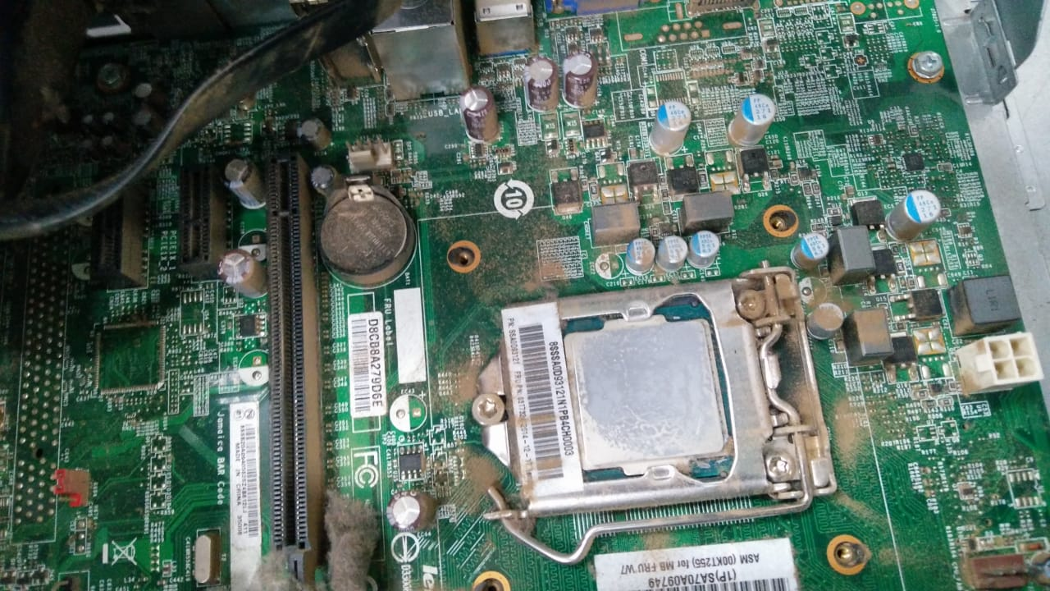

1. Insert the CMOS Battery into the Battery Slot. This battery keeps the date and time settings of the PC, alongwith some extra details about the devices, etc.

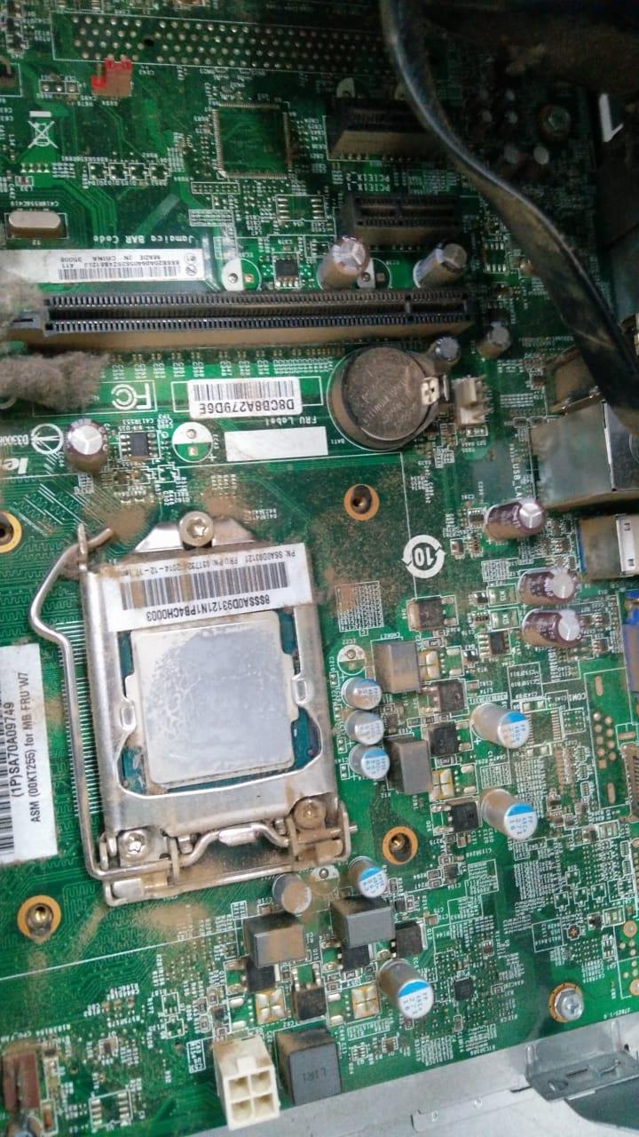

1. Insert the SMPS inside the CPU box and tighten the screws. The Switched-Mode-Power-Supply has a very important Role to play in the working of the CPU, this box provides continuous and safe voltage of electricity as to run all the components of Computer without damaging anything.

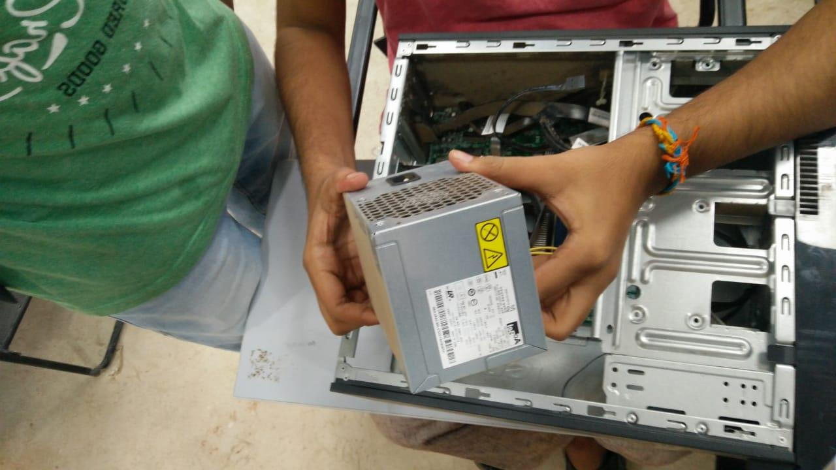

1. Insert the Motherboard inside the CPU Box. And tighten all the screws. This is the most important part in the CPU Box, it is frame/board/Structure on which all primary connection are there which provide a medium to connect I/O, Memory and storage devices to the Processor.

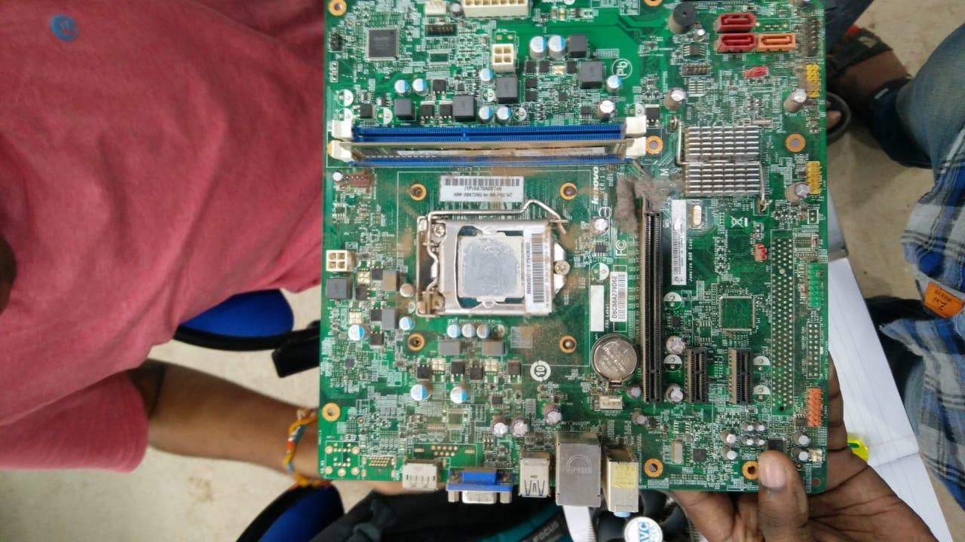

1. Now connect the Power cables. These Cables provide all the power to the motherboard and its components. There is a Single Bigger slot for power( which is the main Power) and two smaller connectors in the CPU we were given.

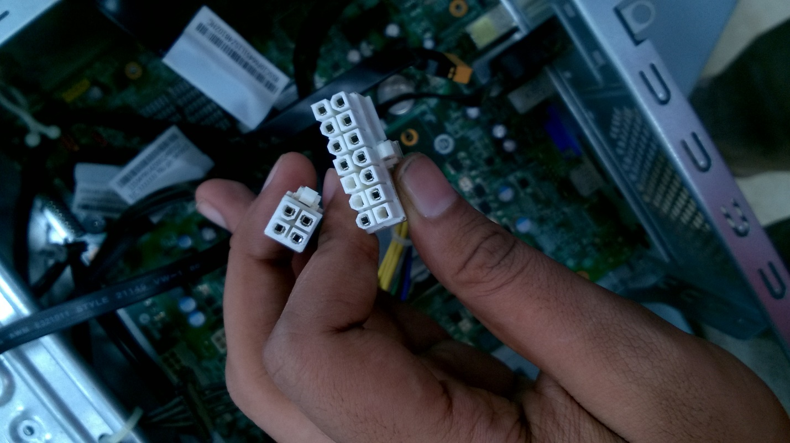

1. Connect the USB, Audio/Microphone and LED cables to the jumpers. These cables are used to allow the motherboard to have more ports than the ports permanently fixed.

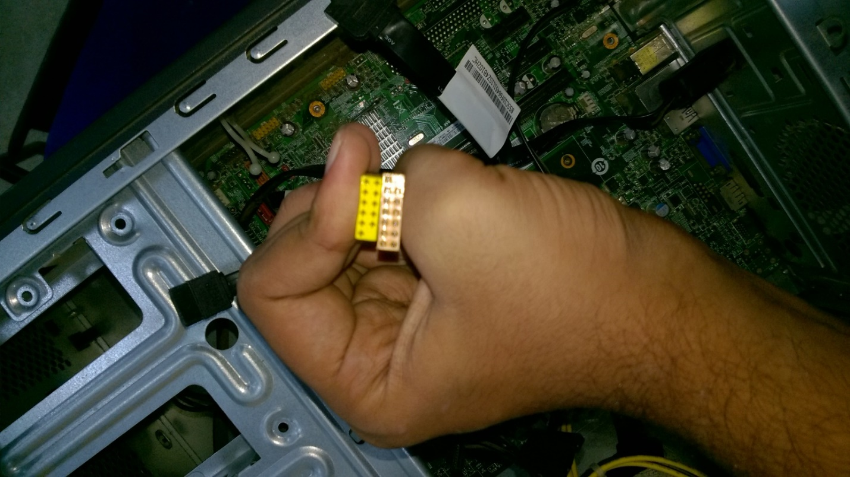

1. Connect the Serial port and Gaming Port connectors to the motherboard. These allow us to connect a Joystick or a Serial Device.

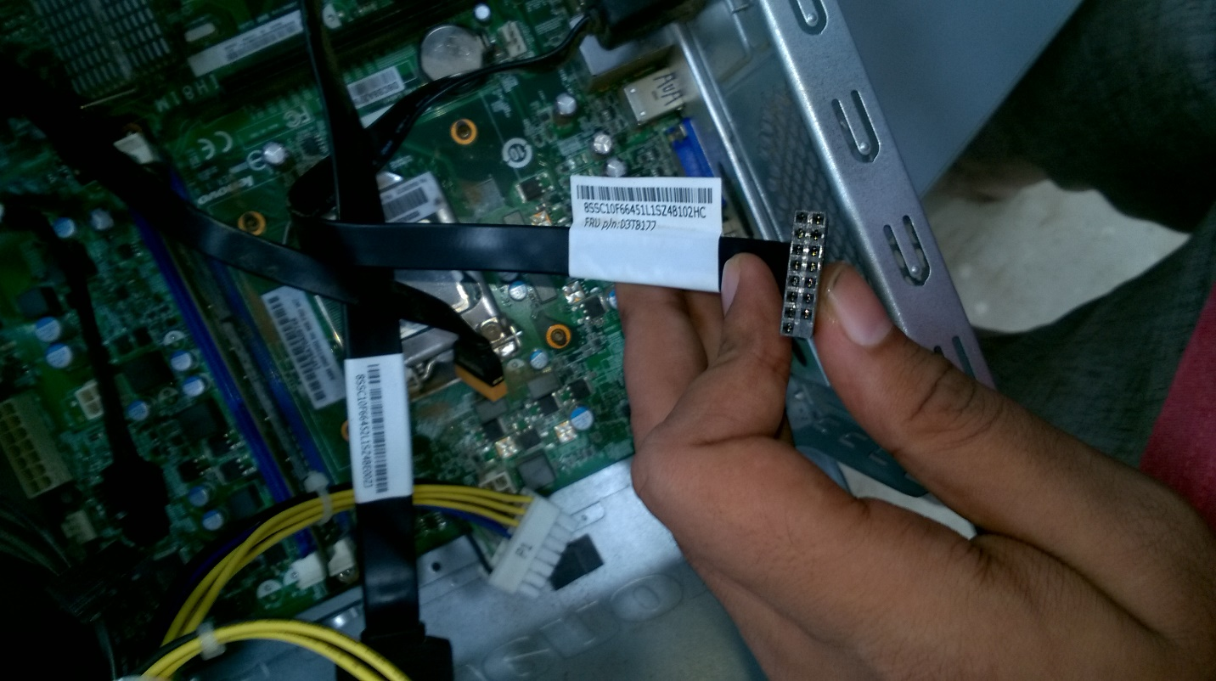 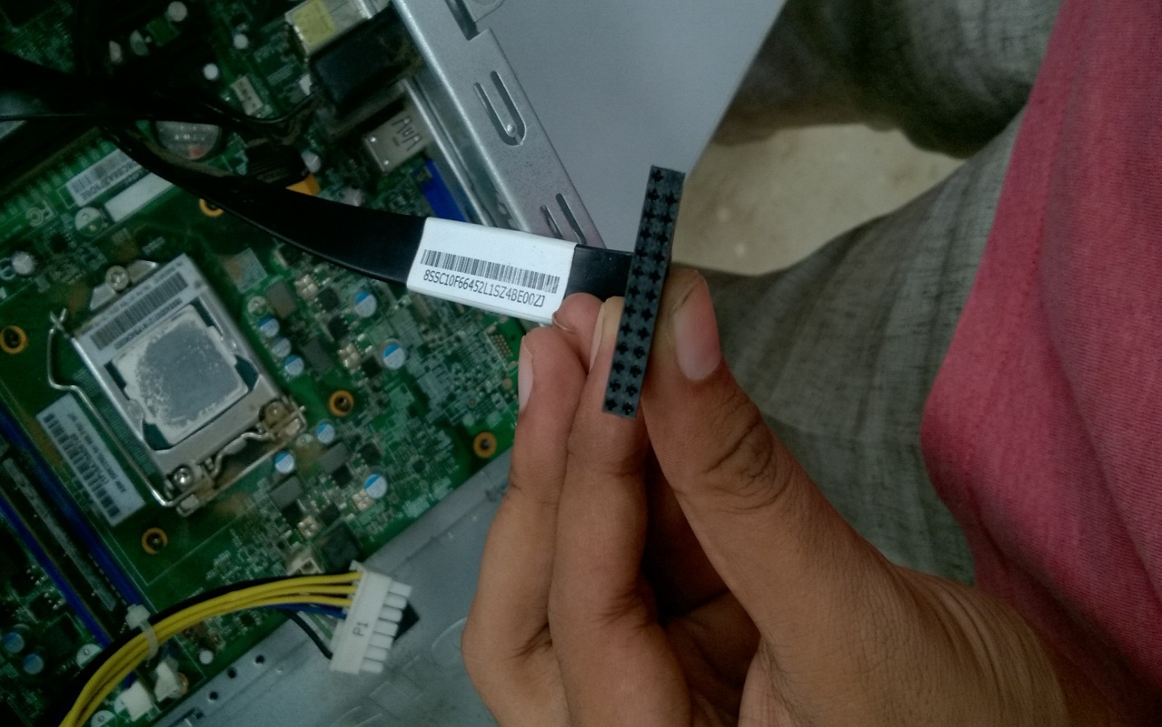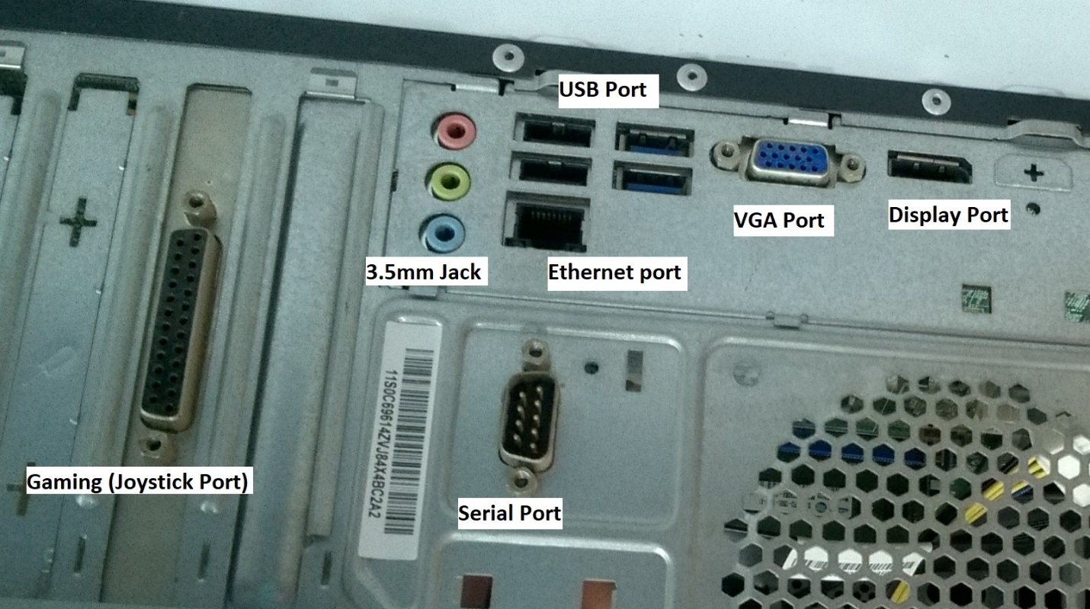

1. Put the heat sink over the processor and tighten the screws. The heat sink is very crucial for the proper working of the CPU it is needed to maintain the temperature of the processor as if temperature is very high the semiconductor circuits will melt or get damaged.

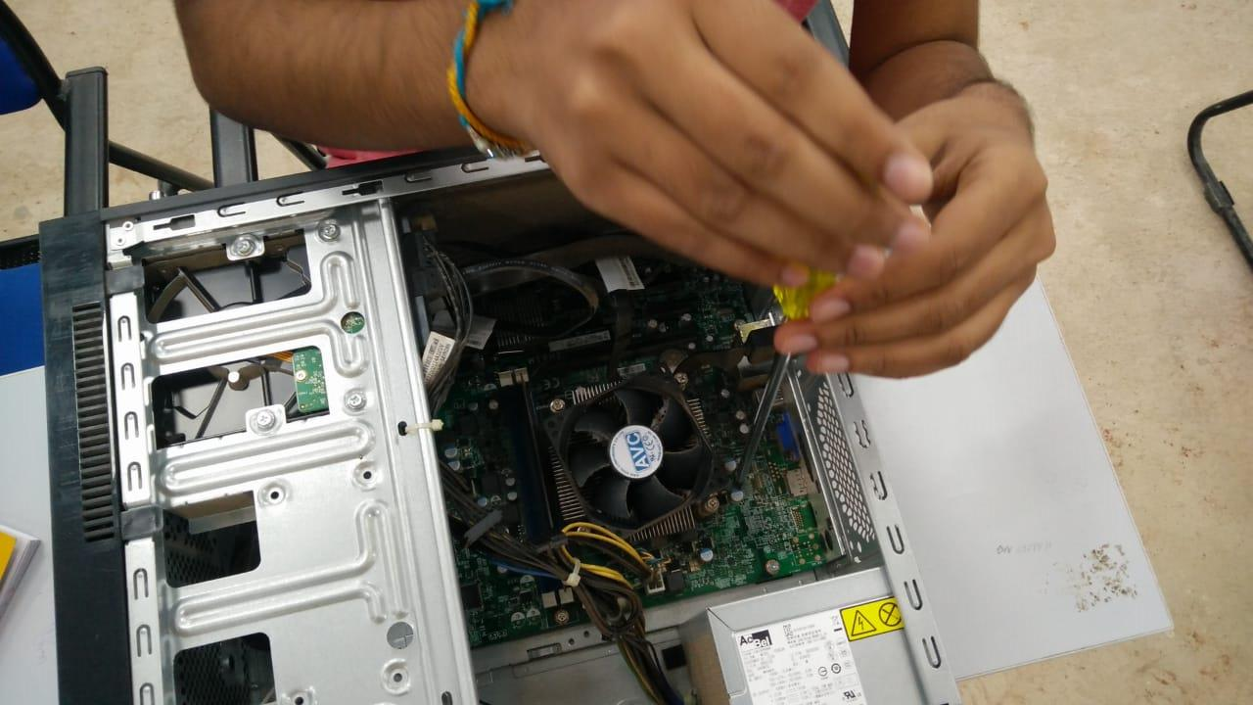

1. Insert the RAM into the RAM Slot. RAM is the main memory we want to load the OS. We don’t want to miss that.
2. Insert the Hard Disk into the cabinet and connect SATA Cables, and power cables to the Hard disk. SATA or Serial ATA is called Serial Advanced Technology Attachment. Is used to Transfer data from storage Devices, such as Hard Disks, CD-ROM, SSD, etc.

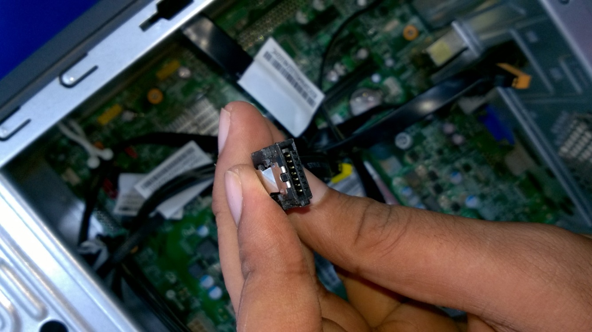 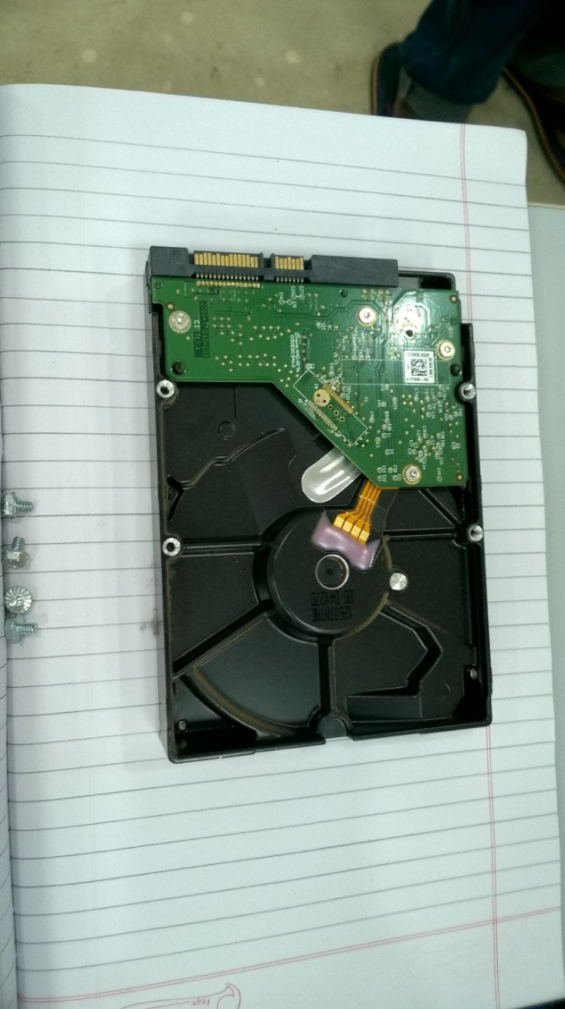

1. Put the CPU cover on the box. Just to keep the dust out and keeping it clean.

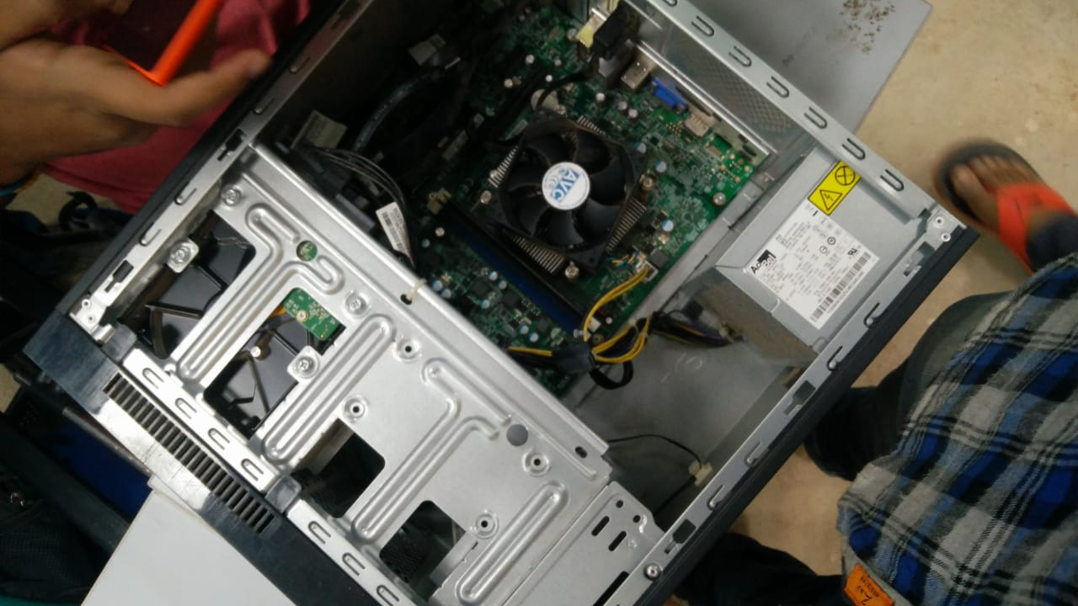

***Your CPU is now assembled.***